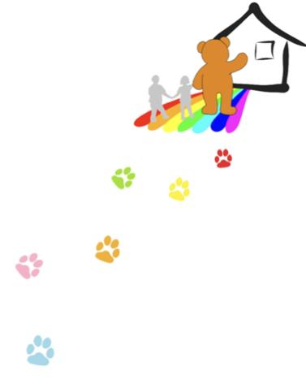
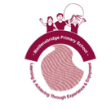

My Starting School Story
My name is

I am going to Maidensbridge Primary School in September.

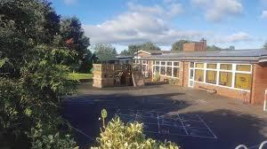

I will be in the Reception class.

Mrs Mason will be my teacher.
Getting Ready for School

When it’s a school day, I have to:

- Get up.
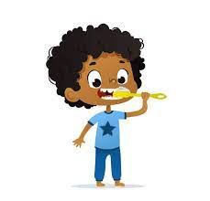

- Eat my breakfast.

- Have a wash, brush my teeth and my hair.
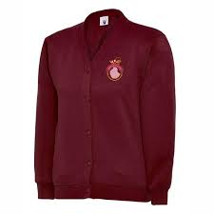

- Put on my school uniform.

- Get my school bag and water bottle.
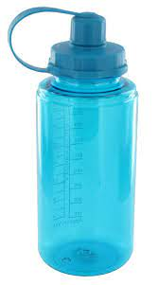

When I have done all of these things, I will be ready for school.

Getting to School

There are lots of ways that I can travel to school with my grown up.
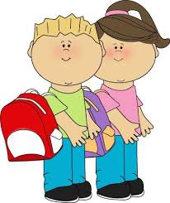

I might walk to school.

I might ride my bike or scooter
to school.
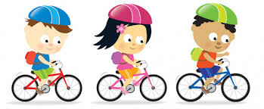

Some days I might go in the car to school.
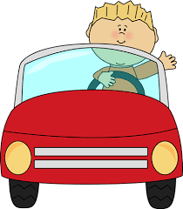

How will I get to my classroom?

I will walk down the school path, across the KS1 playground to the Reception classroom door.

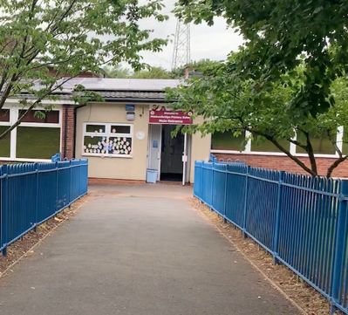

I will need to be brave and go into the classroom without my grown up.

I will say goodbye to my grown up with a smile and a wave.
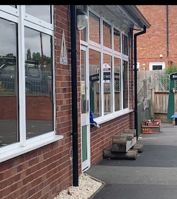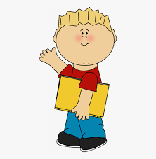

It will be ok! The grown-ups in Reception will look after me and help me find my peg and tray.

My day in Reception

There are lots of fun things to do in my classroom and outdoors.

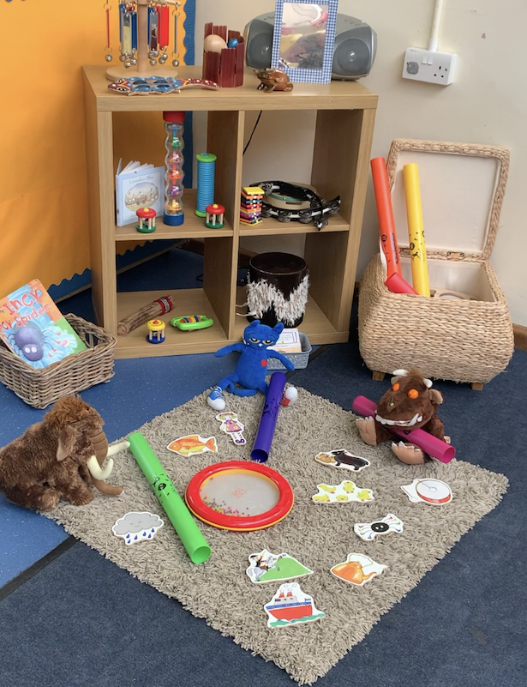
Music Making
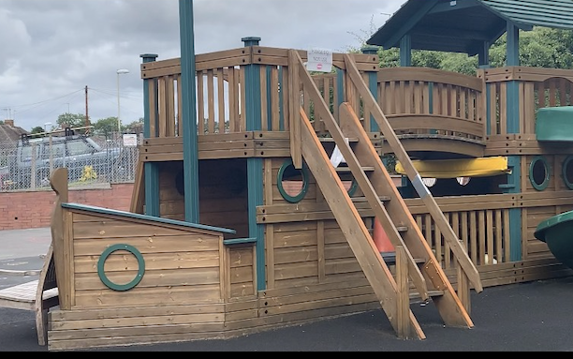
Pirate Ship

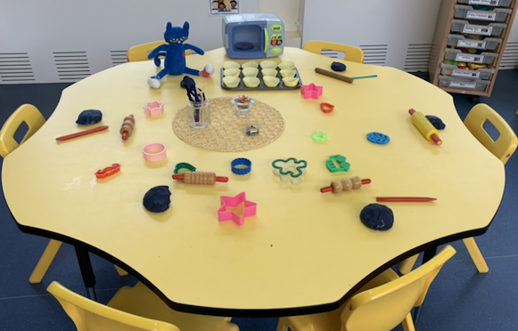
Play Dough

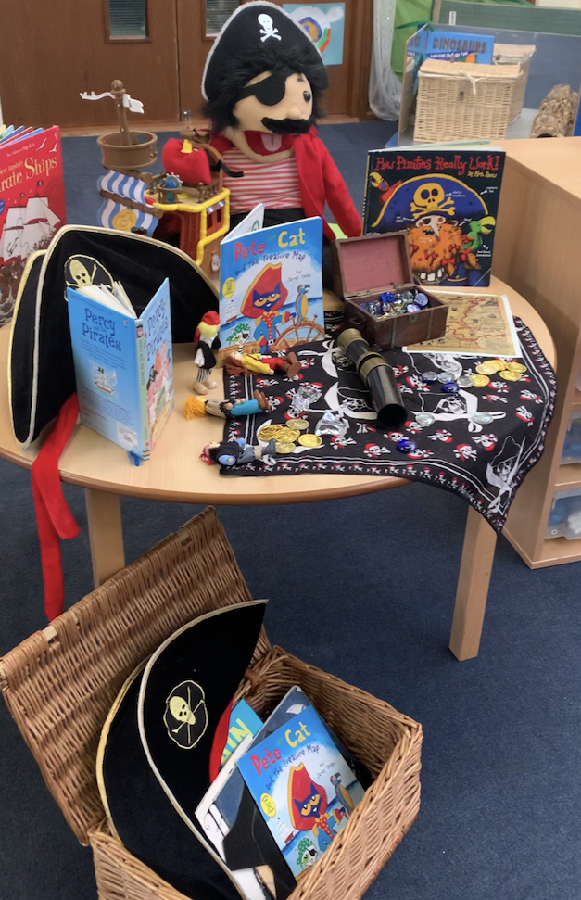
Imaginative Play
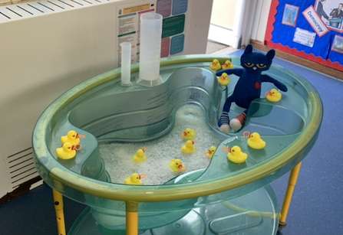
Water Play

Lunchtime

I will either be a packed lunch from home or a school lunch.
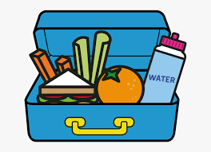

Packed lunch
I will eat my packed lunch with my friends.

I can bring an extra drink to keep me hydrated.
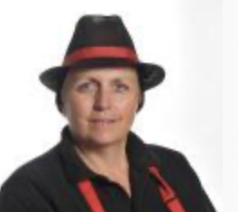

School lunch
Kerry is our school cook.

I can either have a school lunch or a grab bag.
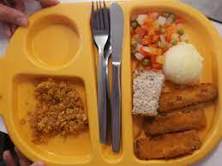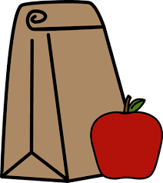
Hometime

My grown up will collect me from the Reception classroom at the end of the school day.

I will be able to tell them all about my day in Reception and the new friends that I have made.

Starting school is exciting!

